Business Process: Pulse Metering

Contact
Business Process Owner | Billing Operations - Billing Solutions
Subject Matter Expert(s) | Amanda De La Cruz, Katherine Martinez, Shannon Whitley
Key Contact | Maya Duarte
Key Role | Customer Services Representative II  Senior Customer Services Representative
Date Created | 5/5/2026

Business Process Overview
Pulse Metering is a service that transmits regular pulses corresponding to electricity consumption to a customer-owned analytics platform, enabling real-time monitoring of energy usage. The Pulse Meter Contract must include the customer name, address, account number, effective date, authorized signatures from the Business Partner and Strategic Account Advisor (SAA), and equipment installation details. Customers are billed a $150 installation charge for each new pulse meter installation or pulse output reconnection, along with a monthly rental fee of $15.50 per meter.
The process begins when our customer requests Pulse Metering. The SAA reviews the request in SAP and Sales Cloud, confirms eligibility, and explains the overall process and associated fees to the customer. If our customer remains interested, the SAA verifies whether an existing KYZ connection is available and, if necessary, initiates a Service Notification (SN) Request through a CSR II. CSR II submits the request and returns the SN number to the SAA. The SAA then prepares the KYZ contract, sends it to the customer, and upon receipt, reviews, signs, and forwards the executed contract to Billing and the customer. Next, the Meter Technician identifies the KYZ connection and swaps the meter if required. Billing processes the meter change, applies the monthly rental fee, Accounting processes the one-time charge, and Billing validates that the first bill is correct and notify SAA completion.
The process concludes when the SAA follows up with the customer to confirm that the work is complete, the bill is accurate and stores the contract.

Business Process Assumptions, Prerequisites, Dependencies
(Assumptions pertaining to the business process)
People | - Assumptions:  - Staff involved understand Pulse Metering setup, contract handling, SAP installation processing, billing coordination, and customer follow-up.  - Our customer provides signatures and responses when needed.  - The Strategic Account Advisor (SAA) is available to review the request, explain the process, and coordinate the contract and follow-up steps.  - Prerequisites:  - Our customer request has been received, and the SAA is available to review the request, explain the process, and coordinate the contract and follow-up steps.  - Dependencies:  - This process depends on coordination between the SAA, CSR II, Meter Technicians, Billing, Accounting, and the customer.
Process | - Assumptions:  - Our customer is eligible for Pulse Metering  - The contract can be completed accurately, the KYZ meter can be identified in SAP, and billing can be established after enrollment.  - The building engineer is onsite when required to support installation.  - Prerequisites:  - The Pulse Meter Contract must be complete, including customer name, address, account number, effective date, and authorized signatures.  - The CSR II must create the Service Notification(SN) for Pulse Meter installation when required.  - Dependencies:  - The process depends on confirming whether there is an existing KYZ connection, identifying the correct meters in SAP, completing the contract, swapping or replacing the meter if needed, processing the meter change in SAP, setting up the pulse meter rental charge, updating the Manual Billing Spreadsheet.  - The effective date is one day after the on-cycle date following the change meter.  - A $150 charge applies per new pulse meter installation or pulse output reconnection.  - A monthly rental fee of $15.50 per meter is entered through SAP installation facts.  - Billing validation occurs on the next on-cycle bill after installation.  - If the customer is requesting removal/disconnect, the SN type differs depending on whether the meter is being replaced or only the pulse outputs are being disconnected.  - If the building engineer is not onsite, the process requires SAA follow-up rather than immediate completion.
Technology | - Assumptions:  - SAP and related billing support tools are available and contain accurate customer and meter information.  - Prerequisites:  - Meter data must be available in SAP, and the system must support installation entry, rate setup, and billing updates.  - Dependencies:  - This process depends on SAP for meter change processing and Installation Fact Operands and Rate Type/Fact Groups, the SN process, and the Manual Billing Spreadsheet for post-enrollment tracking.

Process Flowchart
Pulse Metering Process Mapping As Is.vsdx

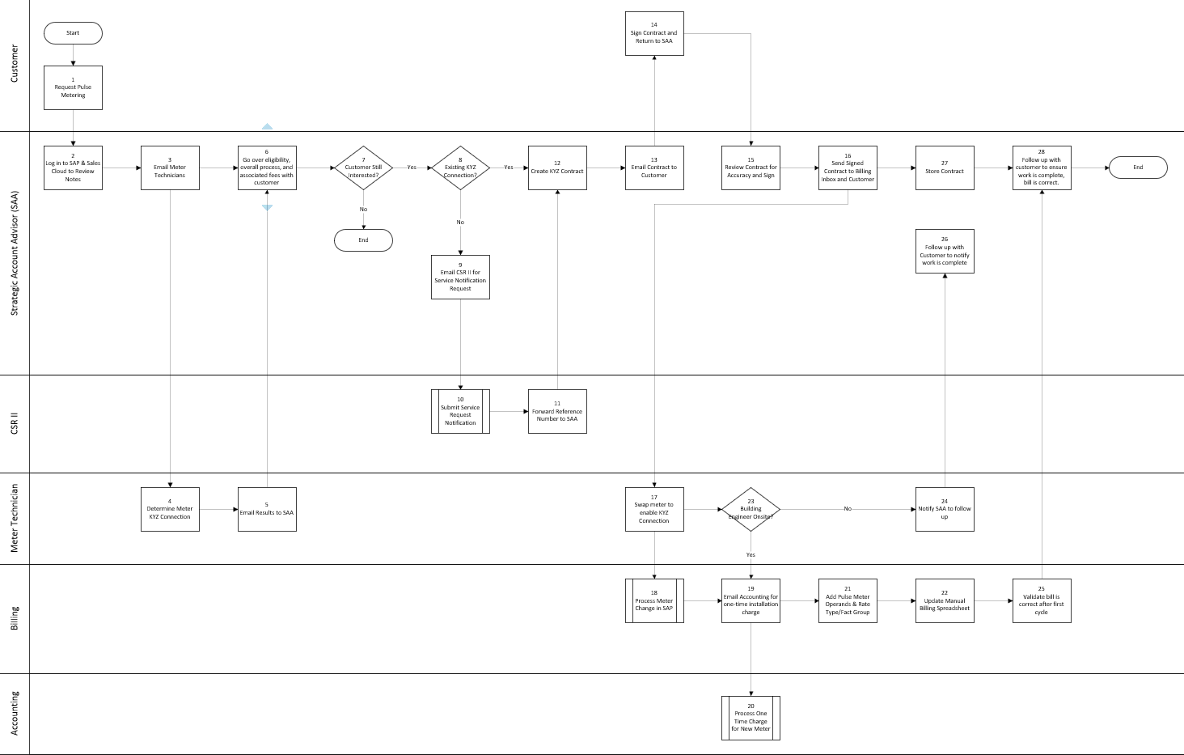

Task Description – Pulse Metering Enroll
Id | Task Description | Procedure
1 | Request Pulse Metering | Our customer requests pulse metering to begin the process.
2 | Log in to SAP & Sales Cloud to Review Notes | SAA reviews account notes and request details in SAP and Sales Cloud.
3 | Email Meter Technicians | SAA emails meter technicians to assess the KYZ connection.
4 | Determine Meter KYZ Connection | Meter technician determines whether a KYZ connection exists.
5 | Email Results to SAA | Meter technician emails the KYZ connection results to the SAA.
6 | Go over eligibility, overall process, and associated fees with customer | SAA reviews eligibility, process steps, and fees with the customer.
7 | Customer Still Interested? | Decision point to confirm whether the customer wants to proceed.
8 | Existing KYZ Connection? | Decision point to confirm whether an existing KYZ connection is available.
9 | Email CSR for Service Notification Request | SAA emails CSR to create a Service Notification request.
10 | Submit Service Request Notification | CSR II submits the Service Notification request.
11 | Forward Reference Number to SAA | CSR II forwards the Service Notification number to the SAA.
12 | Create KYZ Contract | SAA creates the KYZ contract.
13 | Email Contract to Customer | SAA emails the contract to the customer.
14 | Sign Contract and Return to SAA | Customer signs the contract and returns it to the SAA.
15 | Review Contract for Accuracy and Sign | SAA reviews the contract for accuracy and signs it.
16 | Send Signed Contract to Billing Inbox and Customer | SAA sends the signed contract to Billing and the customer.
17 | Swap meter to enable KYZ Connection | Meter Technician swaps the meter to enable the KYZ connection if needed.
18 | Process Meter Change in SAP | Billing processes the meter change in SAP.
19 | Email Accounting for one-time installation charge | Billing emails Accounting for the one-time installation charge.
20 | Process One Time Charge for New Meter | Accounting processes the one-time charge for the new meter.
21 | Add Pulse Meter Operands & Rate Type/Fact Group | Billing applies Installation Fact Operand & Fact Group/Rate Type.
22 | Update Manual Billing Spreadsheet | Billing updates the Manual Billing Spreadsheet.
23 | Building Engineer Onsite? | Decision point to confirm whether the building engineer is onsite.
24 | Notify SAA to follow up | Meter Technician notifies the SAA to follow up if the building engineer is not onsite.
25 | Validate bill is correct after first cycle | Billing validates that the bill is correct after the first cycle.
26 | Follow up with Customer to notify work is complete | SAA follows up with the customer to notify them the work is complete.
27 | Store Contract | SAA stores the completed contract.
28 | Follow up with customer to ensure work is complete, bill is correct, and customer is happy | SAA follows up with the customer to confirm completion, billing accuracy, and satisfaction.

Task Description – Pulse Metering Removal
Id | Task Description | Procedure
1 | Request Pulse Metering Removal | SMUD/Customer request removal of Pulse Metering.
2 | Receive Pulse Metering Removal Request | SAA receives Pulse Metering removal request.
3 | Ensure SN created to remove Pulse Metering | SAA ensures Service Notification (SN) is created to remove Pulse Metering
4 | Process KYZ Request SN | Process KYZ Meter removal or remove connection

Business Rules – Pulse Metering Enroll
Id | Event Name | Business Rules
1 | Pulse Meter Contract | Contract must include customer name, address, account number, effective date, authorized signatures from the Business Partner and Strategic Account Advisor, and equipment installation details.
2 | Effective Date | Effective date is one day after the on-cycle date following the change meter.
4 | KYZ Connection Review | Meter Technician determines whether a KYZ connection exists and emails the result to the SAA.
6 | Customer Eligibility Review | SAA reviews eligibility, overall process, and associated fees with the customer before proceeding.
10 | Service Notification Request | CSR II creates the SN for Pulse Meter install when required.
12 | Contract Execution | SAA creates the KYZ contract, emails it to our customer, reviews the returned contract for accuracy, and signs it before sending it to Billing and the customer.
20 | Installation Charge | Customer is charged $150 per new pulse meter installation or pulse output reconnection.
21 | Monthly Rental Charge | Business Partner is charged a monthly rental fee of $15.50 per meter through SAP installation facts.
22 | Post-Enrollment Tracking | After enrollment, update the Manual Billing Spreadsheet.
25 | Billing Validation | Billing validates that the bill is correct after the first cycle and notify SAA.
28 | Final Follow-Up | SAA follows up with the customer to confirm the work is complete, the bill is correct, and the customer is happy.

Event | Legal Requirements, Rules, and Regulations  Legal documents/ procedures/ requirements to be fulfilled before/at the specified event.
Id | Event | Legal Requirements, Rules and/or Regulations
 |  | N/A

Pain Points and Improvement Opportunities
Pulse Meter Enrollment
    - Streamline the request and contract initiation process by providing a self-service option for our customers to begin the Pulse Metering request, rather than relying entirely on the Strategic Account Advisor (SAA) to distribute the contract and manage the start of the process.
    - Reduce manual coordination across CSR II, Meter Technicians, Billing, and Accounting by standardizing or automating handoffs, which could improve efficiency and reduce delays in setup and billing.
    - Dependency on Service Notifications(SN) should be addressed as part of the S/4HANA upgrade, since the current process relies on creating a SN to support the meter work and coordinate the field activity.
    - Automate the application of the one-time installation fee and ongoing monthly rental fee through Installation Fact operands and Accounting processing to reduce manual effort and improve billing consistency.
    - Fee for installation might require revisiting may not be aligned with other SMUD pricing and charges for similar services.

Departments impacted by process change (Required)

Department | Type of Change(s) | Action Required
Accounting
Billing
Contact Center
Commercial Delivery
Field Metering

Supporting Documentation
(Any subsequent documentation in support of this business process (i.e. business requirements, technical specs, etc.) shall be summarized in the following table.)
Document Type | Link
Business Job-Aid | Pulse Meter Job Aid.pdf
Business Procedures | https://smud.sharepoint.com/sites/retail-product-delivery-and-sales/SitePages/Pulse-Meter.aspx
Process Map | Pulse Metering Process Mapping As Is.vsdx

Business Blueprint Amendments

Any subsequent changes to this business process blueprint after the official document approval shall be summarized in the following table. This document must be reprinted and signed by the authorized representatives.
Version | Author | Description of Change | Approval (Name/Sign) | Date
1.0 | Joshua Dunn | Initial Draft | Maya Duarte | 5/5/2026

